CREATE DATABASE ECOMMERCE;
USE ECOMMERCE;

TABLE CREATION:

mysql> create table customers (customer_id int primary key Auto_increment,name varchar(20) not null,email varchar(30) unique not null,password varchar(30));
Query OK, 0 rows affected (0.09 sec)

mysql> create table products(product_id int primary key Auto_increment,name varchar(20) not null,price decimal(10,2) not null default 0.00,description varchar(50) ,stock_quantity int default 0);
Query OK, 0 rows affected (0.03 sec)

mysql> create table cart(cart_id int primary key Auto_increment,customer_id int,product_id int,quantity int default 0,foreign key(customer_id) references customers (customer_id),foreign key(product_id) references products(product_id));
Query OK, 0 rows affected (0.04 sec)

mysql> CREATE TABLE ORDERS(order_id int primary key,customer_id int,order_date date,total_price decimal(10,2) default 0.00,shipping_address varchar(50),foreign key (customer_id) references customers(customer_id) on delete cascade on update cascade);
Query OK, 0 rows affected (0.05 sec)

mysql> create table order_items(order_item_id int primary key,order_id int,product_id int,quantity int default 0,foreign key(order_id) references orders (order_id) on delete cascade on update cascade,foreign key(product_id) references products(product_id) on delete cascade on update cascade);
Query OK, 0 rows affected (0.05 sec)

INSERTING VALUES::

mysql> INSERT INTO PRODUCTS (name, description, price, stock_quantity) VALUES
-> ('laptop', 'high-performance laptop', 800.00, 10),
-> ('smartphone', 'latest smartphone', 600.00, 15),
-> ('tablet', 'portable tablet', 300.00, 20),
-> ('headphones', 'noise-canceling headphones', 150.00, 30),
-> ('TV', '4K Smart TV', 900.00, 5),
-> ('coffee Maker', 'automatic coffee maker', 50.00, 25),
-> ('refrigerator', 'energy-efficient refrigerator', 700.00, 10),
-> ('microwave oven', 'energy-efficient microwave', 80.00, 15),
-> ('blender', 'high-speed blender', 70.00, 20),
-> ('vacuum cleaner', 'bagless vacuum cleaner', 120.00, 10);
Query OK, 10 rows affected (0.01 sec)
Records: 10 Duplicates: 0 Warnings: 0

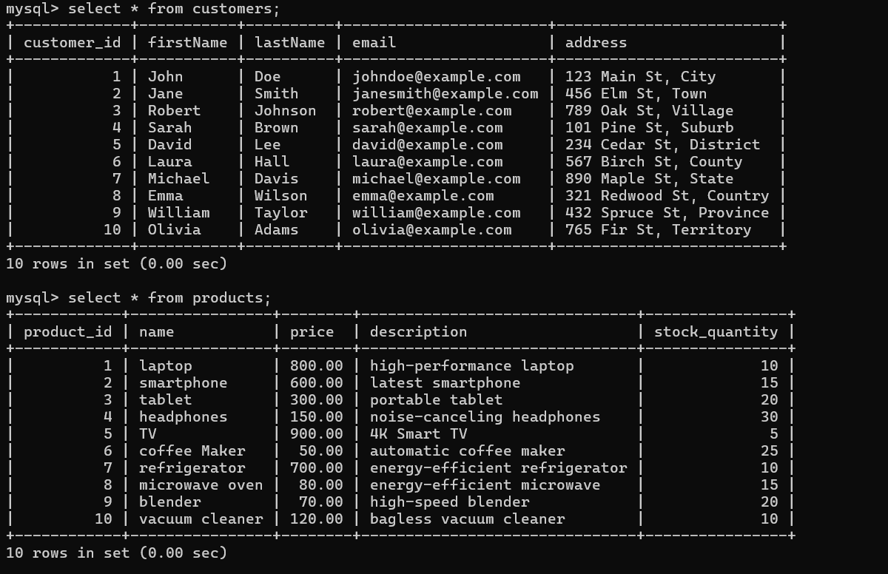

mysql> INSERT INTO customers (firstName, lastName, email, address) VALUES
-> ('John', 'Doe', 'johndoe@example.com', '123 Main St, City'),
-> ('Jane', 'Smith', 'janesmith@example.com', '456 Elm St, Town'),
-> ('Robert', 'Johnson', 'robert@example.com', '789 Oak St, Village'),

-> ('Sarah', 'Brown', 'sarah@example.com', '101 Pine St, Suburb'),
-> ('David', 'Lee', 'david@example.com', '234 Cedar St, District'),
-> ('Laura', 'Hall', 'laura@example.com', '567 Birch St, County'),
-> ('Michael', 'Davis', 'michael@example.com', '890 Maple St, State'),

-> ('Emma', 'Wilson', 'emma@example.com', '321 Redwood St, Country'),
-> ('William', 'Taylor', 'william@example.com', '432 Spruce St, Province'),
-> ('Olivia', 'Adams', 'olivia@example.com', '765 Fir St, Territory');
Query OK, 10 rows affected (0.01 sec)
Records: 10 Duplicates: 0 Warnings: 0

mysql> insert into orders(order_id,customer_id,order_date,total_price) values
-> (1,1,'2023-01-05',1200.00),
-> (2,2,'2023-02-10',900.00),
-> (3,3,'2023-03-15',300.00),
-> (4,4,'2023-04-20',150.00),
-> (5,5,'2023-05-25',1800.00),
-> (6,6,'2023-06-30',400.00),
-> (7,7,'2023-07-05',700.00),
-> (8,8,'2023-08-10',160.00),
-> (9,9,'2023-09-15',140.00),
-> (10,10,'2023-10-20',1400.00);
Query OK, 10 rows affected (0.01 sec)
Records: 10 Duplicates: 0 Warnings: 0

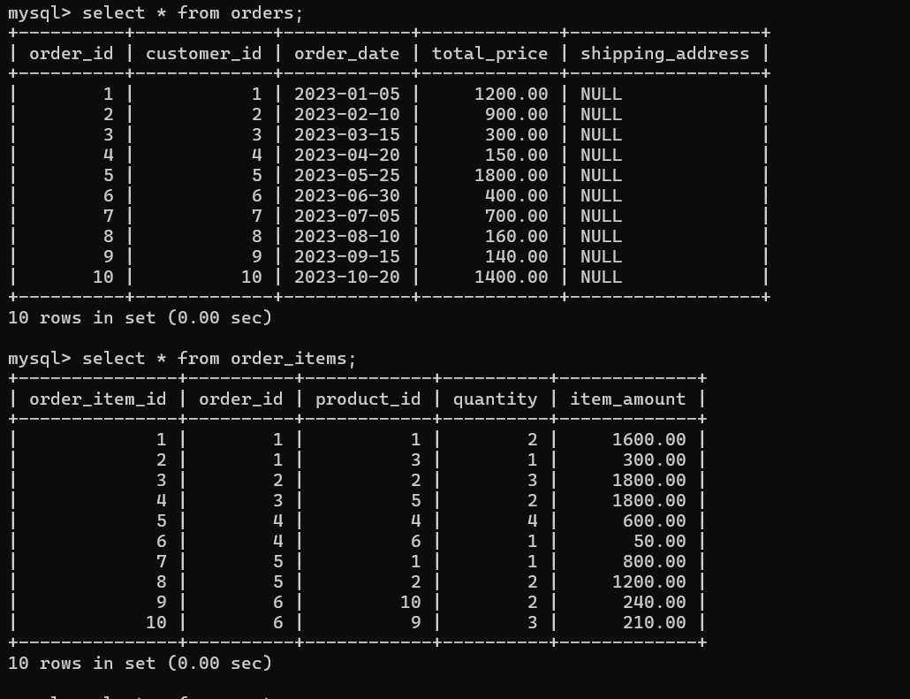mysql> insert into order_items (order_item_id,order_id,product_id,quantity,item_amount) values
-> (1, 1, 1, 2, 1600.00),
-> (2, 1, 3, 1, 300.00),
-> (3, 2, 2, 3, 1800.00),
-> (4, 3, 5, 2, 1800.00),
-> (5, 4, 4, 4, 600.00),
-> (6, 4, 6, 1, 50.00),
-> (7, 5, 1, 1, 800.00),
-> (8, 5, 2, 2, 1200.00),
-> (9, 6, 10, 2, 240.00),
-> (10, 6, 9, 3, 210.00);
Query OK, 10 rows affected (0.01 sec)
Records: 10 Duplicates: 0 Warnings: 0

mysql> insert into cart(customer_id,product_id,quantity) values
-> (1,1,2),
-> (1,3,1),
-> (2,2,3),
-> (3,4,4),
-> (3,5,2),
-> (4,6,1),
-> (5,1,1),
-> (6,10,2),
-> (6,9,3),
-> (7,7,2);
Query OK, 10 rows affected (0.01 sec)
Records: 10 Duplicates: 0 Warnings: 0

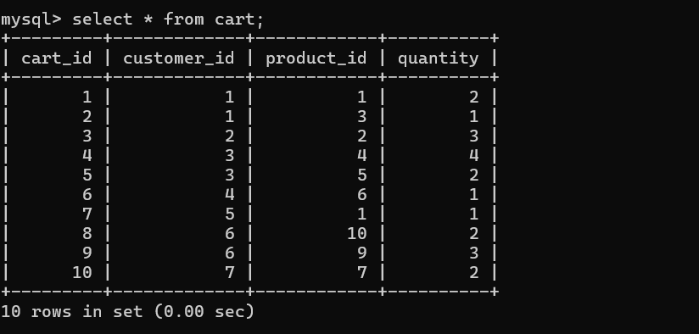
questions and answers:
1. Update refrigerator product price to 800.
mysql> update products set price=800.00 where name='refrigerator';
Query OK, 1 row affected (0.01 sec)
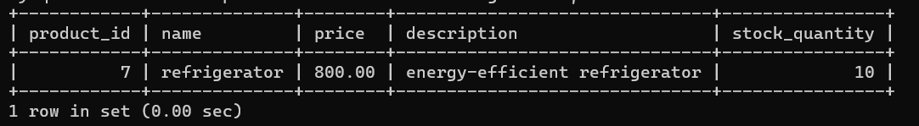
Rows matched: 1 Changed: 1 Warnings: 0
2. Remove all cart items for a specific customer.
mysql> delete from cart where customer_id=5;
Query OK, 1 row affected (0.01 sec)
3. Retrieve Products Priced Below $100.
mysql> select * from products where price<100;
+------------+----------------+-------+----------------------------+----------------+
| product_id | name | price | description | stock_quantity |
+------------+----------------+-------+----------------------------+----------------+
| 6 | coffee Maker | 50.00 | automatic coffee maker | 25 |
| 8 | microwave oven | 80.00 | energy-efficient microwave | 15 |
| 9 | blender | 70.00 | high-speed blender | 20 |
+------------+----------------+-------+----------------------------+----------------+
3 rows in set (0.00 sec)
4. Find Products with Stock Quantity Greater Than 5.
mysql> select name from products where stock_quantity >5;
+----------------+
| name |
+----------------+
| laptop |
| smartphone |
| tablet |
| headphones |
| coffee Maker |
| refrigerator |
| microwave oven |
| blender |
| vacuum cleaner |
+----------------+
9 rows in set (0.00 sec)
5. Retrieve Orders with Total Amount Between $500 and $1000.
mysql> select * from orders where total_price between 500 and 1000;
+----------+-------------+------------+-------------+------------------+
| order_id | customer_id | order_date | total_price | shipping_address |
+----------+-------------+------------+-------------+------------------+
| 2 | 2 | 2023-02-10 | 900.00 | NULL |
| 7 | 7 | 2023-07-05 | 700.00 | NULL |
+----------+-------------+------------+-------------+------------------+
2 rows in set (0.00 sec)
6. Find Products which name end with letter ‘r’.
mysql> select name from products where name like "%r";
+----------------+
| name |
+----------------+
| coffee Maker |
| refrigerator |
| blender |
| vacuum cleaner |
+----------------+
4 rows in set (0.00 sec)
7. Retrieve Cart Items for Customer 5.
mysql> select * from cart where customer_id=5;
Empty set (0.00 sec)
8. Find Customers Who Placed Orders in 2023.
mysql> select customer_id from orders where year(order_date)=2023;
+-------------+
| customer_id |
+-------------+
| 1 |
| 2 |
| 3 |
| 4 |
| 5 |
| 6 |
| 7 |
| 8 |
| 9 |
| 10 |
+-------------+
10 rows in set (0.00 sec)
9. Determine the Minimum Stock Quantity for Each Product Category.
mysql> select name,MIN(stock_quantity) as min_stock from products group by name;
+----------------+-----------+
| name | min_stock |
+----------------+-----------+
| laptop | 10 |
| smartphone | 15 |
| tablet | 20 |
| headphones | 30 |
| TV | 5 |
| coffee Maker | 25 |
| refrigerator | 10 |
| microwave oven | 15 |
| blender | 20 |
| vacuum cleaner | 10 |
+----------------+-----------+
10 rows in set (0.00 sec)
10. Calculate the Total Amount Spent by Each Customer.
mysql> select c.customer_id,c.firstName,sum(o.total_price) as total_amount from customers c join orders o on c.customer_id=o.customer_id group by c.customer_id;
+-------------+-----------+--------------+
| customer_id | firstName | total_amount |
+-------------+-----------+--------------+
| 1 | John | 1200.00 |
| 2 | Jane | 900.00 |
| 3 | Robert | 300.00 |
| 4 | Sarah | 150.00 |
| 5 | David | 1800.00 |
| 6 | Laura | 400.00 |
| 7 | Michael | 700.00 |
| 8 | Emma | 160.00 |
| 9 | William | 140.00 |
| 10 | Olivia | 1400.00 |
+-------------+-----------+--------------+
10 rows in set (0.00 sec)10 rows in set (0.00 sec)
11. Find the Average Order Amount for Each Customer.
mysql> select c.customer_id,c.firstName,avg(o.total_price) as avg_amount from customers c join orders o on c.customer_id=o.customer_id group by c.customer_id;
+-------------+-----------+-------------+
| customer_id | firstName | avg_amount |
+-------------+-----------+-------------+
| 1 | John | 1200.000000 |
| 2 | Jane | 900.000000 |
| 3 | Robert | 300.000000 |
| 4 | Sarah | 150.000000 |
| 5 | David | 1800.000000 |
| 6 | Laura | 400.000000 |
| 7 | Michael | 700.000000 |
| 8 | Emma | 160.000000 |
| 9 | William | 140.000000 |
| 10 | Olivia | 1400.000000 |
+-------------+-----------+-------------+
10 rows in set (0.00 sec)
12. Count the Number of Orders Placed by Each Customer.
mysql> select c.customer_id,c.firstName,count(o.order_id) as order_count from customers c join orders o on c.customer_id=o.customer_id group by c.customer_id;
+-------------+-----------+-------------+
| customer_id | firstName | order_count |
+-------------+-----------+-------------+
| 1 | John | 1 |
| 2 | Jane | 1 |
| 3 | Robert | 1 |
| 4 | Sarah | 1 |
| 5 | David | 1 |
| 6 | Laura | 1 |
| 7 | Michael | 1 |
| 8 | Emma | 1 |
| 9 | William | 1 |
| 10 | Olivia | 1 |
+-------------+-----------+-------------+
10 rows in set (0.00 sec) 10 rows in set (0.00 sec)
13. Find the Maximum Order Amount for Each Customer.
mysql> select c.customer_id,c.firstName,max(o.total_price) as max_amount from customers c join orders o on c.customer_id=o.customer_id group by c.customer_id;
+-------------+-----------+------------+
| customer_id | firstName | max_amount |
+-------------+-----------+------------+
| 1 | John | 1200.00 |
| 2 | Jane | 900.00 |
| 3 | Robert | 300.00 |
| 4 | Sarah | 150.00 |
| 5 | David | 1800.00 |
| 6 | Laura | 400.00 |
| 7 | Michael | 700.00 |
| 8 | Emma | 160.00 |
| 9 | William | 140.00 |
| 10 | Olivia | 1400.00 |
+-------------+-----------+------------+
10 rows in set (0.00 sec)
14. Get Customers Who Placed Orders Totaling Over $1000.
mysql> select c.customer_id,c.firstName,c.lastName from customers c join orders o on c.customer_id=o.customer_id where o.total_price>1000;
+-------------+-----------+----------+
| customer_id | firstName | lastName |
+-------------+-----------+----------+
| 1 | John | Doe |
| 5 | David | Lee |
| 10 | Olivia | Adams |
+-------------+-----------+----------+
3 rows in set (0.00 sec)
15. Subquery to Find Products Not in the Cart.
mysql> select product_id,name from products where product_id not in (select distinct product_id from cart);
+------------+----------------+
| product_id | name |
+------------+----------------+
| 8 | microwave oven |
+------------+----------------+
1 row in set (0.00 sec)
16. Subquery to Find Customers Who Haven't Placed Orders.
mysql> select customer_id,firstName,lastName from customers where customer_id not in (select distinct customer_id from orders);
Empty set (0.00 sec)
17. Subquery to Calculate the Percentage of Total Revenue for a Product.
mysql> select p.product_id,p.name,(select sum(oi.item_amount) from order_items oi where oi.product_id=p.product_id)/(select sum(total_price) from orders) *
100 as total_revenue from products p;
+------------+----------------+---------------+
| product_id | name | total_revenue |
+------------+----------------+---------------+
| 1 | laptop | 33.566434 |
| 2 | smartphone | 41.958042 |
| 3 | tablet | 4.195804 |
| 4 | headphones | 8.391608 |
| 5 | TV | 25.174825 |
| 6 | coffee Maker | 0.699301 |
| 7 | refrigerator | NULL |
| 8 | microwave oven | NULL |
| 9 | blender | 2.937063 |
| 10 | vacuum cleaner | 3.356643 |
+------------+----------------+---------------+
10 rows in set (0.00 sec)
18. Subquery to Find Products with Low Stock.
mysql> select product_id,name from products where stock_quantity<(select avg(stock_quantity) from products) / 2;
+------------+------+
| product_id | name |
+------------+------+
| 5 | TV |
+------------+------+
1 row in set (0.00 sec)
19. Subquery to Find Customers Who Placed High-Value Orders.
mysql> select customer_id,concat(firstName,lastName) as full_name from customers where customer_id in(select distinct customer_id from orders where total_pr
ice>1000);
+-------------+-------------+
| customer_id | full_name |
+-------------+-------------+
| 1 | JohnDoe |
| 5 | DavidLee |
| 10 | OliviaAdams |
+-------------+-------------+
3 rows in set (0.01 sec)

